**Theme changer**

1. **Task Description:**

The task is to implement a toggle switch that allows the user to switch between light and dark modes on a webpage. The switch will display a sun icon in light mode and a moon icon in dark mode. The sun icon will be yellow, and the moon icon will be grey or black, depending on the mode. Additionally, the moon icon will disappear when light mode is active and the sun icon will disappear in dark mode. The design should be responsive to adapt to different screen sizes.

**Key Steps Involved:**

* Created a toggle switch using CSS for light and dark modes.
* Added a sun icon for light mode and a moon icon for dark mode.
* Styled the switch to be responsive, adjusting its size and positioning based on screen width.
* Used opacity changes to hide/show icons depending on the active mode.
* Implemented transitions for smooth switching between light and dark modes.

1. **Task Output Screenshot**

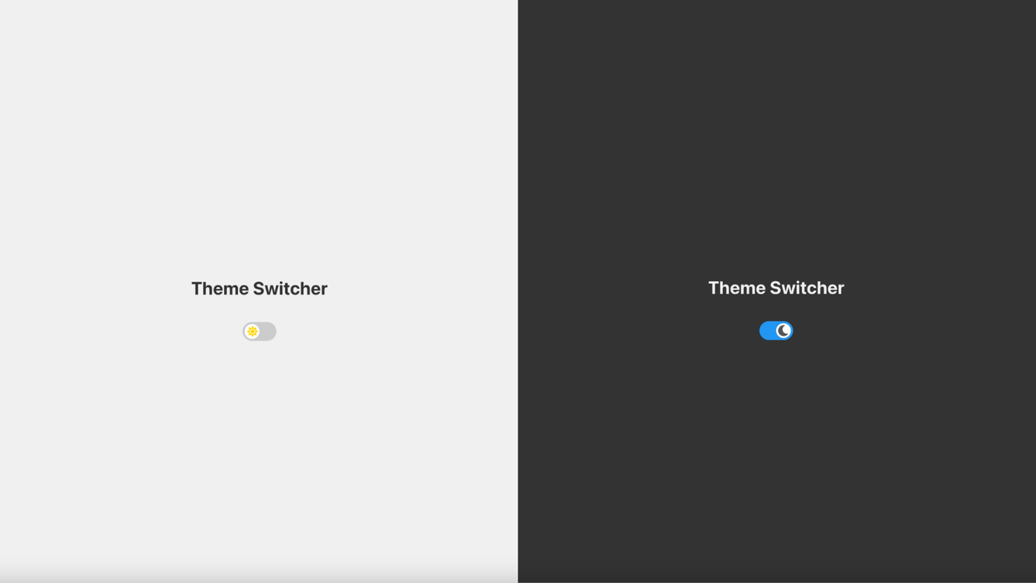

1. **Widget/Algorithm Used In Task**

**HTML Structure:**

* + **Switch**: A custom toggle switch implemented using HTML and CSS. This switch allows users to toggle between light and dark modes.
  + **Icons**: The sun and moon icons are used to visually represent light and dark modes, respectively.

**CSS Styling:**

* + **Flexbox Layout**: Used for centring the content and ensuring the layout adjusts based on screen size.
  + **Positioning**: The sun and moon icons were positioned using absolute and transform properties to align them properly within the switch.
  + **Transitions**: The switch uses CSS transitions for smooth animation when toggling between modes.
  + **Responsive Design**: Media queries were used to adjust the switch size and icon positioning for smaller screens (max-width: 768px and 480px).

**Algorithm:**

* + **Light and Dark Mode Toggle**: The .light and .dark classes are added to the .app container to toggle between light and dark modes. The opacity of the sun and moon icons is controlled based on the active mode.
  + **Opacity Control**: When in light mode, the moon icon is hidden (opacity: 0), and in dark mode, the sun icon is hidden.